- Quality Improvement
- No waiting lying in a corridor (BMJ Open Quality, August 2023)
- Quality control: the misunderstood essential for improvement (Institute for Healthcare Improvement, August 2023)
- Stroke quality improvement project for complex stroke survivors (Academy of Fabulous Stuff, August 2023)
- Improving organising outpatient appointments (Academy of Fabulous Stuff, August 2023)

- Integrated care
- The state of integrated care systems 2022/2023: riding the storm (NHS Confederation, August 2023)
- Exploring and understanding the VCSE sector in provider collaboratives (NHS Confederation, August 2023)
- Ambulance services and integrated care systems: lessons for effective collaboration (NHS Confederation, August 2023)
- Remote monitoring technology and virtual clinical support reduces pressure on acute trusts and GP surgeries (Integrated Care Northamptonshire, August 2023)

- Patients & people
- Patients to get the help they need more quickly as new Unscheduled Care Hub is launched in Bedfordshire (Bedfordshire, Luton and Milton Keynes Health and Care Partnership, August 2023)
- Back to basics: understanding lived experience and intersectionality in health and care (King’s Fund, August 2023)
- What are people telling us about accessing and paying for social care? (Healthwatch, August 2023)
- Making every relationship matter: a practitioner toolkit for relational care with older people (Housing Learning and Improvement Network, August 2023)
- Your experiences of getting prescription medication (Healthwatch, August 2023)

- NHS strategy & performance
- Workforce Plan: a missed opportunity for palliative care? (British Journal of Community Nursing, August 2023) Requires an OpenAthens password *
- Growing numbers of delayed discharges from community hospitals (Nuffield Trust, August 2023)
- How feasible are the NHS Long Term Workforce Plan commitments on training? (Health Foundation, August 2023)
- Social health insurance: be careful what you wish for (Health Foundation, August 2023)
- Building community health and care capacity: reflections from other countries (Nuffield Trust, August 2023)
- Major conditions strategy: case for change and our strategic framework (Department of Health and Social Care, August 2023)
- How long are patients waiting for a GP appointment in England? (Nuffield Trust, August 2023)
- Elective recovery taskforce: implementation plan (Department of Health and Social Care, August 2023)

- Population health & prevention
- How to successfully implement population health management: a scoping review (BMC Health Services Research, August 2023)
- A bitter taste? Exploring the political constraints on public health policies (Social Market Foundation, August 2023)
- Social needs among people living with mental health difficulties (Centre for Mental Health, August 2023)
- Health inequalities: improving accountability in the NHS (Institute of Health Equity, August 2023)

- Technology & data
- Personalised electronic health programme for recovery after major abdominal surgery: a multicentre, single-blind, randomised, placebo-controlled trial (Lancet Digital Health, August 2023)
- Artificial intelligence-based model to classify cardiac functions from chest radiographs: a multi-institutional, retrospective model development and validation study (Lancet Digital Health, August 2023)
- £13 million for 22 AI for health research projects (UK Research and Innovation, August 2023)
- Embedding equity into every step of adverse event analysis (Institute for Healthcare Improvement, August 2023)
- National data guardian focuses on assurance, value and transparency on NHS’s Federated Data Platform (Health Tech Newspaper, August 2023)

7. Events & Training
QSIR Virtual- contact QSIRVirtual@geh.nhs.uk QSIR Practitioner- contact QSIR@Swft.nhs.uk
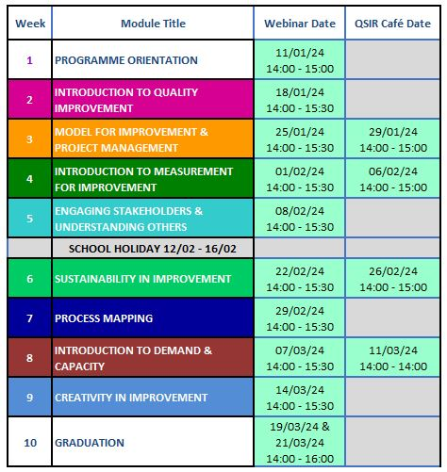
*Register for a free Open Athens password at https://openathens.nice.org.uk/

