h

**



*NHS information support for evidence-based practice*

**Alert** **121**

***Resources published in July-August 2023***

**Content**

**Patient Experience and Safety** 1

**Managing and Leading People** 3

**Education and Professional Practice** 5

**Finance and Procurement** 6

**Service Design and Commissioning** 7

**Quality Improvement and Innovation** 9

**Public Health** 10

**NHS Long Term Workforce Plan: Assessing training commitment feasibility**

The [NHS Long Term Workforce Plan](https://www.england.nhs.uk/long-read/accessible-nhs-long-term-workforce-plan/)sets out an ambitious plan to increase training places across NHS clinical professions, and outlines proposals to address an expected shortfall of between 260,000 and 360,000 staff by 2036/37. [The Health Foundation’s short analysis](https://www.health.org.uk/publications/long-reads/how-feasible-are-the-nhs-long-term-workforce-plan-commitments-on-training) looks at the implications of these commitments for the health care education system and wider workforce planning in England.

To meet these commitments, the proportion of first-year higher education students training to be NHS clinical professionals would need to increase by 50% over this period. Based on current trends, this would mean that students training to be NHS clinical professionals would make up around 1 in 6 of all first-year students in 2031/32, up from 1 in 9 in 2022/23.

This raises questions about how to ensure universities and the NHS can scale up capacity rapidly enough, and what the commitments mean for the makeup of England’s student population and future labour market. Boosting training numbers is vital to meet future demand for care, but this will be insufficient by itself. This commitment needs to be matched with policy action on retaining existing staff and ensuring the NHS is a more attractive place to work, as well as the appropriate capital investment in the buildings, equipment and technology needed to sustain this plan.

**Full article by The Health Foundation:** <https://www.health.org.uk/publications/long-reads/how-feasible-are-the-nhs-long-term-workforce-plan-commitments-on-training>

**KnowledgeShare Team**

**William Harvey Library, GETEC, George Eliot Hospital NHS Trust, College St, Nuneaton, CV10 7DJ.  
*email:*** [***library@geh.nhs.uk***](mailto:library@geh.nhs.uk) **Education Centre Library, Warwick Hospital, Lakin Road, Warwick, CV34 5BW. Email:** [**library@swft.nhs.uk**](mailto:library@swft.nhs.uk)

**NHS Long Term Workforce Plan:** <https://www.england.nhs.uk/long-read/accessible-nhs-long-term-workforce-plan/>

**Patient Experience and Safety**

**Guideline / Policy**

[**Improving patient safety culture: a practical guide.**](https://www.england.nhs.uk/publication/improving-patient-safety-culture-a-practical-guide/)  
NHS England; 2023.  
<https://www.england.nhs.uk/publication/improving-patient-safety-culture-a-practical-guide/>  
[This guide brings together existing approaches to shifting safety culture as a resource to support teams to understand their safety culture and how to approach improving it.]

**Evidence-Based Summary**

[**Hospice at home can enable people to have a good death in the place of their choosing.**](https://evidence.nihr.ac.uk/alert/hospice-at-home-can-enable-people-to-have-a-good-death-in-the-place-of-their-choosing/)  
NIHR Evidence; 2023.  
<https://evidence.nihr.ac.uk/alert/hospice-at-home-can-enable-people-to-have-a-good-death-in-the-place-of-their-choosing/>  
[Hospice at home provides end-of-life care for people who would like to die at home. A review in England found that these services support a good death (as reported by the bereaved carer) and enable most people to die in their preferred location (usually at home).]  
  
[**How to keep prescribing safe over the longer-term.**](https://evidence.nihr.ac.uk/alert/how-to-keep-prescribing-safe-over-the-longer-term/)  
NIHR Evidence; 2023.  
<https://evidence.nihr.ac.uk/alert/how-to-keep-prescribing-safe-over-the-longer-term/>  
[The team analysed 48 academic and professional documents on prescribing safety in general practice. The researchers identified 5 strategies to increase the long-term success of the prescribing interventions.]

**Original Research**

**Mixed-methods study examining family carers' perceptions of the relationship between intrahospital transitions and patient readiness for discharge.** [[Abstract]](https://www.ncbi.nlm.nih.gov/pubmed/36100445)  
Bristol AA. *BMJ Quality & Safety* 2023;32(8):447-456.  
[Check for full-text availability](https://libkey.io/36100445)  
  
**Stats on the desats: alarm fatigue and the implications for patient safety.** [[Abstract]](https://www.ncbi.nlm.nih.gov/pubmed/37474134)  
Anderson HR. *BMJ Open Quality* 2023;12(3):e002262.  
[Check for full-text availability](https://libkey.io/37474134)

**Report**

[**Harm caused by delays in transferring patients to the right place of care: final report.**](https://www.hsib.org.uk/investigations-and-reports/harm-caused-by-delays-in-transferring-patients-to-the-right-place-of-care/harm-caused-by-delays-in-transferring-patients-to-the-right-place-of-care/)  
Healthcare Safety Investigation Branch (HSIB); 2023.  
<https://www.hsib.org.uk/investigations-and-reports/harm-caused-by-delays-in-transferring-patients-to-the-right-place-of-care/harm-caused-by-delays-in-transferring-patients-to-the-right-place-of-care/>  
[This national investigation finds that issues relating to patient flow affect ambulance crews’ ability to hand over patient care to emergency department (ED) staff. It also finds that EDs are routinely at, or exceeding, their maximum capacity and this has an impact on their ability to provide safe care.]  
  
[**How do the public and NHS staff feel about virtual wards?**](https://www.health.org.uk/news-and-comment/charts-and-infographics/how-do-the-public-and-nhs-staff-feel-about-virtual-wards)  
The Health Foundation; 2023.  
<https://www.health.org.uk/news-and-comment/charts-and-infographics/how-do-the-public-and-nhs-staff-feel-about-virtual-wards>  
[The analysis suggests that while the UK public is on balance supportive of virtual wards, a lack of understanding of the term may be holding back public support for them.]

**To register for an NHS OpenAthens username and password visit:**

**bit.ly/athensreg**

[**NHS at 75: Insights Report.**](https://www.nationalvoices.org.uk/publications/our-publications/nhs-75-insights-report)  
National Voices; 2023.  
<https://www.nationalvoices.org.uk/publications/our-publications/nhs-75-insights-report>  
[National Voices brought together around 50 members and people with lived experience in response to an invitation from the NHS Assembly. Insights were sought around five key themes: prevention; personalisation; participation; primary and community care; and partnerships. This report finds that any future developments within the NHS must focus on responding to what matters to people and ensuring that the basic building blocks are in place, such as equity of access and simple communication.]  
  
[**The limits of shared decision making.**](https://ebm.bmj.com/content/28/4/218) [[Abstract]](https://www.ncbi.nlm.nih.gov/pubmed/36522136)  
Elwyn G. *BMJ Evidence-Based Medicine* 2023;28(4):218-221.  
[Check for full-text availability](https://libkey.io/36522136)  
[Considering the historical underappreciation of the need for patient involvement in their care, there is a need for more SDM. Clinicians have a duty of care to the people they advise, and, in our view, to involve them carefully in decisions: they also have obligations to their profession, to society and to science. It helps to be clear when those other obligations take precedence and therefore limit the use of SDM.]

**Managing and Leading People**

**Guideline / Policy**

[**Sexual safety in healthcare: organisational charter.**](https://www.england.nhs.uk/long-read/sexual-safety-in-healthcare-organisational-charter/)  
NHS England; 2023.  
<https://www.england.nhs.uk/long-read/sexual-safety-in-healthcare-organisational-charter/>  
[Signatories to this charter commit to taking and enforcing a zero-tolerance approach to any unwanted, inappropriate and/or harmful sexual behaviours within the workplace, and to 10 core principles and actions to help achieve this. It is expected that signatories will implement all 10 commitments by July 2024.]

[**Transgender and non-binary EDI in the workplace.**](https://www.cipd.org/uk/knowledge/guides/transgender-non-binary/)  
Chartered Institute of Personnel and Development (CIPD); 2023.  
<https://www.cipd.org/uk/knowledge/guides/transgender-non-binary/>  
[This guide will help people professionals, employers and people managers take a proactive and informed approach to supporting transgender and non-binary people at work, as part of a broader equality, diversity and inclusion policy.]

[**NHS long term workforce plan.**](https://www.england.nhs.uk/publication/nhs-long-term-workforce-plan/)  
NHS England; 2023.  
<https://www.england.nhs.uk/publication/nhs-long-term-workforce-plan/>  
[This plan sets out how the NHS will address existing vacancies and meet the challenges of a growing and ageing population by recruiting and retaining hundreds of thousands more staff over 15 years and working in new ways. It also sets out long-term workforce projections. It aims to reduce reliance on expensive agency spend that could cut the bill for taxpayers by around £10 billion between 2030/31 and 2036/37. £2.4 billion to fund additional education and training places over five years.]

**Follow us on social media: @GEHSWFTLibrary**

**Evidence-Based Summary**

[**Effective people managers: Evidence review.**](https://www.cipd.org/en/knowledge/evidence-reviews/people-managers/)  
Chartered Institute of Personnel and Development (CIPD); 2023.  
<https://www.cipd.org/en/knowledge/evidence-reviews/people-managers/>  
[This evidence review draws together the best available evidence to explore why people managers are important, what a good people manager looks like, and how to develop effective people managers.]

**To obtain copies of journal articles use our online request forms:**

[**click here**](https://gehswft.wordpress.ptfs-europe.co.uk/information-resources/geh-kls-hub/)

**Report**

[**A picture of health? Examining the state of leadership and management in healthcare.**](https://www.smf.co.uk/publications/management-in-healthcare/)  
Social Market Foundation; 2023.  
<https://www.smf.co.uk/publications/management-in-healthcare/>  
[This report examines the role that leadership and management can play in both lifting up the tail of underperforming health care providers and fostering more 'outstanding' health care providers.]  
  
[**Burnout in healthcare: risk factors and solutions.**](https://www.som.org.uk/new-strategy-needed-tackle-healthcare-burnout-crisis)  
Society of Occupational Medicine (SOM); 2023.  
<https://www.som.org.uk/new-strategy-needed-tackle-healthcare-burnout-crisis>  
[This report recommends primary, secondary, and tertiary interventions throughout the healthcare sector to protect employees against burnout and enable those returning from absence because of the condition to do so effectively and safely.]

[**Data science skills in the UK workforce.**](https://post.parliament.uk/research-briefings/post-pn-0697/)  
Parliamentary Office of Science and Technology (POST); 2023.  
<https://post.parliament.uk/research-briefings/post-pn-0697/>  
[This POSTnote looks at specialist data skills in the UK, including for artificial intelligence. It considers demand and supply, workforce demographics, challenges, and initiatives to increase supply.]  
  
[**Fear and futility: what does the staff survey tell us about speaking up in the NHS?**](https://nationalguardian.org.uk/2023/06/08/fear-and-futility/)  
National Guardians Office; 2023.  
<https://nationalguardian.org.uk/2023/06/08/fear-and-futility/>  
[While the results have improved since Freedom to Speak Up guardians were first implemented, the results show a fall in NHS workers’ confidence to speak up. Of particular concern is the marked fall in how safe people feel to raise a clinical concern.]  
  
[**The practice of collaborative leadership: across health and care services.**](https://www.kingsfund.org.uk/publications/practice-collaborative-leadership)  
The King's Fund; 2023.  
<https://www.kingsfund.org.uk/publications/practice-collaborative-leadership>  
[This report shares insights and evidence about how to collaborate well to build a stronger collaborative ethos across health and care services. This report draws on interview and survey data from senior leaders working in integrated care boards, NHS providers, local government and the voluntary, community and social enterprise sector, and shares insights and evidence about how to collaborate well.]

**Systematic Review / Meta-Analysis**  
**Workplace interventions to improve well-being and reduce burnout for nurses, physicians and allied healthcare professionals: a systematic review.** [[Abstract]](https://www.ncbi.nlm.nih.gov/pubmed/37385740)  
Cohen C. *BMJ Open* 2023;13(6):e071203.  
[Check for full-text availability](https://libkey.io/37385740)  
[The review found that interventions benefitted healthcare workers by increasing well-being, engagement. It is noted that the outcomes of numerous studies were impacted by design limitations that is, no control/waitlist control, and/or no post intervention follow-up.]

**Toolkit**

[**NHS England Fit and Proper Person Test Framework for board members.**](https://www.england.nhs.uk/publication/nhs-england-fit-and-proper-person-test-framework-for-board-members/)  
NHS England; 2023.  
<https://www.england.nhs.uk/publication/nhs-england-fit-and-proper-person-test-framework-for-board-members/>  
[NHS England has developed a Fit and Proper Person Test (FPPT) Framework in response to recommendations made by Tom Kark KC in his 2019 review of the FPPT (the Kark Review). This also takes into account the requirements of the Care Quality Commission (CQC) in relation to directors being fit and proper for their roles. This framework should be read in conjunction with associated guidance documents.]

**Keep up to date with your favourite journals via the KnowledgeShare table of contents (TOC) service.**

**To sign up to this service, go to our** [**online form.**](https://gehswft.wordpress.ptfs-europe.co.uk/new-users/how-do-i-keep-up-to-date/)

[**Six Steps Methodology to Integrated Workforce Planning: checklist.**](https://www.skillsforhealth.org.uk/info-hub/six-steps-methodology-planning-checklist/)  
Skills for Health; 2023.  
<https://www.skillsforhealth.org.uk/info-hub/six-steps-methodology-planning-checklist/>  
[This checklist provides a quick reference guide of the key considerations of each of the steps in integrated workforce planning. This document can be used to help with planning, ensuring that leaders reflect on and incorporate the level of detail needed to effectively plan their workforce needs.]

**Education and Professional Practice**

**Guideline / Policy**

[**A new dawn for nursing: 2023-2027.**](https://www.rcn.org.uk/Professional-Development/publications/rcn-five-year-strategy-uk-pub-010-891)  
Royal College of Nursing (RCN); 2023.  
<https://www.rcn.org.uk/Professional-Development/publications/rcn-five-year-strategy-uk-pub-010-891>  
[Our five-year strategy aims to inspire, champion and support the nursing community to deliver the best possible care.]  
  
[**Good Medical Practice 2024.**](https://www.gmc-uk.org/ethical-guidance/good-medical-practice-2024)  
General Medical Council (GMC); 2023.  
<https://www.gmc-uk.org/ethical-guidance/good-medical-practice-2024>  
[Good Medical Practice sets out the standards of patient care and professional behaviour expected of all doctors in the UK, across all specialties, career stages and sectors. The standards focus on behaviours and values which support good team work, make everyone feel safe to speak up, and empower doctors to provide quality care. Updated version comes into effect on 30 January 2024.]  
  
[**Russell Group principles on the use of generative AI tools in education.**](https://russellgroup.ac.uk/news/new-principles-on-use-of-ai-in-education/)  
Russell Group; 2023.  
<https://russellgroup.ac.uk/news/new-principles-on-use-of-ai-in-education/>  
[A new set of principles has been created to help universities ensure students and staff are ‘AI literate’ so they can capitalise on the opportunities technological breakthroughs provide for teaching and learning. Developed in partnership with AI and educational experts, the new principles recognise the risks and opportunities of generative AI and commit Russell Group universities to helping staff and students become leaders in an increasingly AI-enabled world.]

**Original Research**

[**Can clinical decision support systems be an asset in medical education? An experimental approach.**](https://bmcmededuc.biomedcentral.com/articles/10.1186/s12909-023-04568-8) [[Abstract]](https://www.ncbi.nlm.nih.gov/pubmed/37568144)  
Kafke SD. *BMC Medical Education* 2023;23(1):570.  
[Check for full-text availability](https://libkey.io/37568144)  
  
[**Evaluating the UK’s first national prescribing assessment for GPs in training.**](https://bjgpopen.org/content/early/2023/08/16/BJGPO.2023.0044)  
Knox R. *BJGP Open* 2023;:10.3399/BJGPO.2023.0044.

**Report**

[**Pragmatic and open science-based solution to a current problem in the reporting of living systematic reviews.**](https://ebm.bmj.com/content/28/4/267) [[Abstract]](https://www.ncbi.nlm.nih.gov/pubmed/36351782)  
Metzendorf MI. *BMJ Evidence-Based Medicine* 2023;28(4):267-272.  
[Check for full-text availability](https://libkey.io/36351782)  
[Living systematic reviews are an increasingly common approach to keeping reviews up to date, in which new relevant studies are incorporated as they become available, so as to inform healthcare policy and practice in a timely manner. We describe a new method to transparently report the living evidence surveillance process that occurs between published LSR versions.]  
  
[**How feasible are the NHS Long Term Workforce Plan commitments on training?**](https://www.health.org.uk/publications/long-reads/how-feasible-are-the-nhs-long-term-workforce-plan-commitments-on-training)  
The Health Foundation; 2023.  
<https://www.health.org.uk/publications/long-reads/how-feasible-are-the-nhs-long-term-workforce-plan-commitments-on-training>  
[The NHS LTWP makes important commitments to increase training intakes across several NHS clinical staff groups in England by 2031/32. This short analysis looks at the implications of these commitments for the health care education system and wider workforce planning in England.]

**Systematic Review / Meta-Analysis**

[**How are fitness to practise processes applied in UK higher education institutions? A systematic review.**](https://doi.org/10.1016/j.nepr.2023.103691)  
Jadzinski M. *Nurse Education in Practice* 2023;71:103691.  
[This systematic review will establish how Fitness to Practise (FtP) processes are applied in UK Higher Education Institutions (HEI), in relation to both Health and Care Profession Council or Nursing and Midwifery Council approved programmes. Regulatory bodies provide HEIs with strategic guidance on policy which can be interpreted and incorporated into existing policies; this means that there is no standard approach to the FtP process in HEI settings, allowing individual policies and procedures.]

**Toolkit**

[**Directory of board level learning and development opportunities.**](https://www.england.nhs.uk/long-read/directory-of-board-level-learning-and-development-opportunities/)  
NHS England; 2023.  
<https://www.england.nhs.uk/long-read/directory-of-board-level-learning-and-development-opportunities/>  
[This framework aims to help senior board members to strengthen board governance, boost leadership and improve patient safety.]

**Finance and Procurement**

**Report**

[**Creating better health value: understanding the economic impact of NHS spending by care setting.**](https://www.nhsconfed.org/publications/creating-better-health-value-economic-impact-care-setting)  
NHS Confederation; 2023.  
<https://www.nhsconfed.org/publications/creating-better-health-value-economic-impact-care-setting>  
[This research (commissioned by the NHS Confederation and conducted by Carnall Farrar) examines where the greatest returns on investment from spending in the NHS can come from to impact the wider domestic economy. It shows that when high levels of funding are ploughed into primary and community care the economic gains are significant.]

**For all your e-resources try the Library Hub.** [**http://tiny.cc/GEHKLSHub**](http://tiny.cc/GEHKLSHub)

[**Implications of the NHS workforce plan.**](https://ifs.org.uk/publications/implications-nhs-workforce-plan)  
Institute for Fiscal Studies (IFS); 2023.  
<https://ifs.org.uk/publications/implications-nhs-workforce-plan>  
[In June 2023, NHS England published its long-term workforce plan. The plan aims to increase the number of staff employed by the English NHS from around 1.5 million in 2021–22 to between 2.3 and 2.4 million in 2036–37. This report examines the potential implications for NHS funding.]

[**System risk management: key considerations for evolving arrangements.**](https://www.hfma.org.uk/publications/details/system-risk-management)  
Healthcare Financial Management Association (HFMA); 2023.  
<https://www.hfma.org.uk/publications/details/system-risk-management>  
[Integrated care systems (ICSs) are developing their approach to system risk management following the enactment of the Health and Care Act 2022. This joint briefing from the Good Governance Institute (GGI) and the HFMA aims to support systems as they work on system risk management. It includes two case studies and sets out the key challenges, opportunities and considerations involved in effective system risk management.]  
[**online form**](https://www.uhsussex.nhs.uk/professionals/knowledge-and-libraries/brighton-hove-and-haywards-heath-libraries/updates/#journal-alerts)  
[**The economic impact of over-the-counter products in the UK.**](https://www.frontier-economics.com/uk/en/news-and-articles/news/news-article-i10429-the-economic-impact-of-over-the-counter-medicines/)  
Frontier Economics; 2023.  
<https://www.frontier-economics.com/uk/en/news-and-articles/news/news-article-i10429-the-economic-impact-of-over-the-counter-medicines/>  
[This report, commissioned by the consumer health care association Proprietary Association of Great Britain (PAGB), finds that the UK over-the-counter (OTC) sector saves the NHS £6.4 billion of prescription and appointment costs each year. The report also demonstrates the value of encouraging people to take a more proactive approach to their health by widening the scope of how they self-care.]

**Service Design and Commissioning**

**Guideline / Policy**

[**Diagnostic imaging reporting turnaround times.**](https://www.england.nhs.uk/long-read/diagnostic-imaging-reporting-turnaround-times/)  
NHS England; 2023.  
<https://www.england.nhs.uk/long-read/diagnostic-imaging-reporting-turnaround-times/>  
[New national turnaround time (TAT) guidance in England for imaging reporting TATs across clinical pathways, including the maximum timeframe within which all imaging must be reported.]  
  
[**Elective recovery taskforce: implementation plan.**](https://www.gov.uk/government/publications/elective-recovery-taskforce-implementation-plan)  
Department of Health and Social Care (DHSC); 2023.  
<https://www.gov.uk/government/publications/elective-recovery-taskforce-implementation-plan>  
[A plan to turbocharge recovery of the COVID-19 backlog in elective care by leveraging the capacity across the whole system and empowering patients to choose where they are treated.]

**Report**

[**A vision for the future of primary care.**](https://www.nationalvoices.org.uk/publications/our-publications/vision-future-primary-care)  
National Voices; 2023.  
<https://www.nationalvoices.org.uk/publications/our-publications/vision-future-primary-care>  
[Through insights gathered within a coalition of health and care charities, this report identifies nine proposals for the reform of primary care that could make a difference for people living with health conditions and disability, and in particular people from groups that experience health inequalities, while also supporting the primary care workforce.]

[**Ambulance services and integrated care systems: lessons for effective collaboration.**](https://www.nhsconfed.org/publications/ambulance-services-and-integrated-care-systems-lessons-effective-collaboration)  
NHS Confederation; 2023.  
<https://www.nhsconfed.org/publications/ambulance-services-and-integrated-care-systems-lessons-effective-collaboration>  
[Four enablers of effective collaboration between integrated care systems and ambulance services.]  
  
[**Building community health and care capacity: reflections from other countries.**](https://www.nuffieldtrust.org.uk/resource/building-community-health-and-care-capacity-reflections-from-other-countries)  
Nuffield Trust; 2023.  
<https://www.nuffieldtrust.org.uk/resource/building-community-health-and-care-capacity-reflections-from-other-countries>  
[This analysis finds that other countries have been on the same mission and have had more success. It looks internationally at how performance in England compares and how other countries have succeeded in building up community health and care services to understand what might be learnt.]  
**app**

[**BMJ Best Practice**](https://bestpractice.bmj.com/info/) **- Use it to find the latest evidence-based information to support your practice.**

**Also available as an** [**app**](https://bestpractice.bmj.com/info/app/) **on Apple or Google Play store.**

[**Experiences and understandings of co-production in adult social care: findings from SCIE’s Co-production Survey 2023.**](https://www.scie.org.uk/co-production/supporting/breaking-down-barriers)  
Social Care Institute for Excellence (SCIE); 2023.  
<https://www.scie.org.uk/co-production/supporting/breaking-down-barriers>  
[Over the last few decades, the concept of ‘co-production’ has gained significant attention within the social care sector.The recommendations put forward throughout this report aim to bridge the gaps in understanding of what co-production entails, how it should be implemented, and why we need it.]

[**Exploring and understanding the VCSE sector in provider collaboratives.**](https://www.nhsconfed.org/publications/exploring-and-understanding-vcse-sector-provider-collaboratives)  
NHS Confederation; 2023.  
<https://www.nhsconfed.org/publications/exploring-and-understanding-vcse-sector-provider-collaboratives>  
[Insights into the unique offer the voluntary, community and social enterprise sector has to support provider collaboratives.]  
  
[**Fit for the Future: A Modern and Sustainable NHS Providing Accessible and Personalised Care for All.**](https://www.institute.global/insights/public-services/fit-for-future-modern-sustainable-nhs-providing-accessible-personalised-care-for-all)  
Tony Blair Institute for Global Change; 2023.  
<https://www.institute.global/insights/public-services/fit-for-future-modern-sustainable-nhs-providing-accessible-personalised-care-for-all>  
[This report proposes how we can keep the principle of health care based on need not on the ability to pay – the originating principle of the NHS – but change radically the way the system works, to incorporate not only what modern technology makes possible, but also the best from health-care systems around the world.]  
  
[**Getting the fundamentals right: how to better prepare for discharge pressures next winter.**](https://www.nuffieldtrust.org.uk/news-item/getting-the-fundamentals-right-how-to-better-prepare-for-discharge-pressures-next-winter)  
Nuffield Trust; 2023.  
<https://www.nuffieldtrust.org.uk/news-item/getting-the-fundamentals-right-how-to-better-prepare-for-discharge-pressures-next-winter>  
[Delayed discharges, where a patient is medically fit to leave hospital but is not discharged, were a particular problem in England last winter. This long read highlights some possible solutions to help better prepare health and care services for discharge pressures next winter.]

[**The state of integrated care systems 2022/23: Riding the storm.**](https://www.nhsconfed.org/publications/state-integrated-care-systems-202223)  
NHS Confederation; 2023.  
<https://www.nhsconfed.org/publications/state-integrated-care-systems-202223>  
[This report aims to provide insights into the successes and challenges of integrated care systems (ICSs) one year after their formal establishment. Building on the Hewitt review and through engagement with NHS Confederation members, it identifies key recommendations that the NHS Confederation believes will give ICSs the conditions they need to deliver for the local population they serve.]

**Systematic Review / Meta-Analysis**

**Healthcare workers' perceptions and experiences of primary healthcare integration: a scoping review of qualitative evidence.** [[Abstract]](https://www.ncbi.nlm.nih.gov/pubmed/37434293)  
Moloi H. *Cochrane Database of Systematic Reviews* 2023;7:CD013603.  
[Check for full-text availability](https://libkey.io/37434293)  
[Researchers and decision‐makers need to understand the relationship between different integration approaches and contexts, and the ways in which healthcare workers influence the impacts of this integration. The study categories we have developed can help researchers to understand these approaches and identify more focused questions for future systematic reviews.]

[**A rapid review of the effectiveness, efficiency, and acceptability of surgical hubs in supporting planned care activity.**](https://www.medrxiv.org/content/10.1101/2023.04.20.23288815v1)  
medRxiv; 2023.  
<https://www.medrxiv.org/content/10.1101/2023.04.20.23288815v1>  
[[This article is a preprint and has not been peer-reviewed.] This rapid review aimed to assess the effectiveness, efficiency, and acceptability of surgical hubs in supporting planned care activity, to inform the implementation of these hubs in Wales. The evidence relating to the impact of surgical hubs on clinical outcomes appeared to be heterogenous and limited. Included studies did not appear to control for the impact of the COVID-19 pandemic on outcomes.]

**Quality Improvement and Innovation**

**Guideline / Policy**

[**Preparing your organisation for AI use.**](https://www.cipd.org/uk/knowledge/guides/preparing-organisation-ai-use/)  
Chartered Institute of Personnel and Development (CIPD); 2023.  
<https://www.cipd.org/uk/knowledge/guides/preparing-organisation-ai-use/>  
[Guidance on how to prepare a user policy on generative AI for your workplace and how this technology can be used to support HR functions.]  
  
[**Scaling innovation within healthcare systems: practical considerations.**](https://www.nhsconfed.org/publications/scaling-innovation-within-healthcare-systems)  
NHS Confederation; 2023.  
<https://www.nhsconfed.org/publications/scaling-innovation-within-healthcare-systems>  
[This guide comes in response to NHS Confederation member feedback on challenges to innovation in the NHS. It provides practical pointers for innovators and system decision-makers on how to successfully adopt and scale proven innovations. The guide has been endorsed by the AHSN Network.]

**Evidence-Based Summary**  
[**Rapid evaluation of service innovations in health and social care: key considerations.**](https://www.journalslibrary.nihr.ac.uk/hsdr/BTNU5673/#/abstract)  
Smith J. *Health Services and Delivery Research* 2023;11(11):BTNU5673.  
[This essay explores the emerging field of rapid evaluation in health and social care, drawing out the ways in which it is distinctive from or similar to other forms of applied research. It draws closely on the experience of two National Institute for Health and Care Research rapid service evaluation teams established in 2018. Reflection on the rapid evaluation teams’ body of work is used to highlight methodological and operational considerations for researchers, practitioners and policy-makers]

**Report**

**Advanced non-medical roles within surgery and their engagement with assistive health technologies.** [[Abstract]](https://www.ncbi.nlm.nih.gov/pubmed/37495401)  
Bradburn A. *British Journal of Nursing* 2023;32(14):672-676.  
[Check for full-text availability](https://libkey.io/37495401)  
[The role of the surgical care practitioner (SCP) is common in UK surgical centres. The SCP role focuses on technical skills, developing a skillset that is highly effective during traditional open surgical procedures. It requires further investigation as technology-assisted surgeries become more common.]  
  
[**Delays to NHS care: Understanding the impact.**](https://www.healthwatch.co.uk/report/2023-07-27/delays-nhs-care-understanding-impact)  
Healthwatch; 2023.  
<https://www.healthwatch.co.uk/report/2023-07-27/delays-nhs-care-understanding-impact>  
[Healthwatch England commissioned a survey of 1,084 people who have seen their NHS care either cancelled or postponed this year to understand the extent of disruption to care amid rising waiting lists, workforce issues and industrial action, and other pressures on the NHS.]

**All NICE guidance is available from the NICE web site:** [**www.nice.org.uk**](http://www.nice.org.uk)**.**

**Support and resources to maximise uptake and use:** [**https://www.nice.org.uk/about/what-we-do/into-practice**](https://www.nice.org.uk/about/what-we-do/into-practice)

**2**

[**Transfer of care discovery report.**](https://theprsb.org/transferofcarediscoveryreport/)  
Professional Record Standards Body; 2023.  
<https://theprsb.org/transferofcarediscoveryreport/>  
[The eDischarge Information Record Standard was first published in 2015. Despite significant investment in programme initiatives, the widespread implementation of the standards has been slow. This report identifies the challenges that have inhibited the adoption of the standard, makes recommendations for improvements and sets out the anticipated benefits that this will bring.]  
  
[**Whole System Quality: ​A Unified Approach to Building Responsive, Resilient Health Care Systems.**](https://www.ihi.org/resources/Pages/IHIWhitePapers/whole-system-quality.aspx)  
Institute for Healthcare Improvement (IHI); 2023.  
<https://www.ihi.org/resources/Pages/IHIWhitePapers/whole-system-quality.aspx>  
[This IHI White Paper proposes a more holistic approach to quality management — whole system quality — that enables organizations to close the gap between the quality that customers are currently receiving and the quality that they could be receiving by integrating quality planning, quality control, and quality improvement activities across multiple levels of the system.]

**Toolkit**

[**How Strong is Your Anchor? A Measurement Toolkit for Health Anchors.**](https://uclpartners.com/project/anchor-strategy-and-change-network/)  
UCL Partners; 2023.  
<https://uclpartners.com/project/anchor-strategy-and-change-network/>  
[Anchor institutions are typically large-scale, non-profit organisations whose long-term sustainability is tied to the wellbeing of the population they serve. This toolkit aims to provide guidance and support to local health anchors and their partners, helping them to capture their activity and impact.]

**Public Health**

**Evidence-Based Summary**

[**Carrots and sticks: Can governments do without public health regulation?**](https://www.smf.co.uk/publications/carrots-and-sticks-public-health/)  
Social Market Foundation (SMF); 2023.  
<https://www.smf.co.uk/publications/carrots-and-sticks-public-health/>  
[This is the first of three papers exploring tobacco, alcohol, obesity and gambling policy. It compares different types of policy approach, and concludes that more ‘interventionist’ and apparently politically challenging measures, such as strict regulations on availability and taxes, tend to be more effective.]

**Fast answers anytime, anywhere with the** [**ClinicalKey**](https://www.clinicalkey.com/#!/) **Mobile App**

**Find it on the App Store or** [**contact us**](mailto:library@geh.nhs.uk) **for more information.**

**\***[**NHS OpenAthens**](http://openathens.nice.org.uk/)**username and password required.**

[**Not by choice – the unequal impact of the COVID-19 pandemic on disempowered ethnic minority and migrant communities.**](https://raceequalityfoundation.org.uk/health-and-care/not-by-choice-the-unequal-impact-of-the-covid-19-pandemic/)  
Race Equality Foundation (REF); 2023.  
<https://raceequalityfoundation.org.uk/health-and-care/not-by-choice-the-unequal-impact-of-the-covid-19-pandemic/>  
[Too many of the policy decisions made during the Covid-19 pandemic either did not understand the evidence on inequality or ignored it, and that this was particularly true for ethnic minorities and migrants. The pandemic revealed the true scale of inequality in the UK and findings conclude that better, evidence-based and responsive policy and practice could have changed these outcomes.]

**Report**

[**Health security from the ground up: 5 lessons for the future of the UKHSA.**](https://reform.uk/publications/health-security-from-the-ground-up-5-lessons-for-the-future-of-the-ukhsa/)  
Reform; 2023.  
<https://reform.uk/publications/health-security-from-the-ground-up-5-lessons-for-the-future-of-the-ukhsa/>  
[This paper explores the shortcomings in the English response to COVID-19 and presents five policy ideas which would help strengthen the UKHSA and improve the UK’s resilience in the face of future health crises.]  
  
[**Interim Report launch: A new framework for tackling poverty.**](https://povertystrategycommission.org.uk/tackling-poverty/)  
Poverty Strategy Commission (PSC); 2023.  
<https://povertystrategycommission.org.uk/tackling-poverty/>  
[The Commission’s Interim Report summarises the findings of the Commission’s work since 2022. The overall rate of poverty in the UK has remained stubbornly high, a third of children are in poverty and 7% of the population is in deep poverty.]

[**Prevention in health and social care: vaccination.**](https://publications.parliament.uk/pa/cm5803/cmselect/cmhealth/1764/report.html)  
UK Parliament: Health and Social Care Committee; 2023.  
<https://publications.parliament.uk/pa/cm5803/cmselect/cmhealth/1764/report.html>  
[Recent NHS data shows vaccine coverage fell in 13 out of 14 routine programmes for children up to 5 years old in 2021-22 and immunisation rates have been consistently dropping in recent years.]  
  
[**Strategic transport objectives inquiry.**](https://www.adph.org.uk/wp-content/uploads/2023/08/Accessible-ADPH-response-to-the-Strategic-transport-objectives-inquiry.pdf)  
Association of Directors of Public Health (ADPH); 2023.  
<https://www.adph.org.uk/wp-content/uploads/2023/08/Accessible-ADPH-response-to-the-Strategic-transport-objectives-inquiry.pdf>  
[Transport plays a vital role in supporting the delivery of many areas of wider government policy and has important implications for our health. As such, there should be an overarching national transport strategy to lay out the vision for a sustainable transport network.]  
  
[**The Broken Plate 2023: The State of the Nation’s Food System.**](https://foodfoundation.org.uk/publication/broken-plate-2023)  
The Food Foundation; 2023.  
<https://foodfoundation.org.uk/publication/broken-plate-2023>  
[The report assesses eight key metrics which provide an indication of the state of our food environment and demonstrate how difficult it is to eat healthily and sustainably when the affordability, availability and appeal of unhealthy and unsustainable foods point us in the opposite direction..]

**Systematic Review / Meta-Analysis**  
**Healthy eating interventions delivered in early childhood education and care settings for improving the diet of children aged six months to six years.** [[Abstract]](https://www.ncbi.nlm.nih.gov/pubmed/37606067)  
Yoong SL. *Cochrane Database of Systematic Reviews* 2023;8:CD013862.  
[Check for full-text availability](https://libkey.io/37606067)  
[ECEC-based healthy eating interventions may improve child diet quality slightly, but the evidence is very uncertain, and likely increase child fruit consumption slightly. There is uncertainty about the effect of ECEC-based healthy eating interventions on vegetable consumption. ECEC-based healthy eating interventions may result in little to no difference in child consumption of non-core foods and sugar-sweetened beverages. [Abstract continues]]

***KnowledgeShare*: Update your knowledge, share your knowledge**

**What is KnowledgeShare?**

KnowledgeShare makes it easier to access personalised resources and services from the Library and Knowledge Service. The library service uses KnowledgeShare to provide services to you (including search requests, information skills teaching and evidence updates) and you can log in with your NHS OpenAthens account to access these services directly.

We are committed to safeguarding your information. The information you supply will be used to contact you about services or resources you have requested from the Library and Knowledge Service. For further information on how we keep your information secure, and your rights to access it, read the full [**KnowledgeShare Privacy Policy**](https://www.knowledgeshare.nhs.uk/index.php?PageID=help_privacy)**.**

**How do I access it?**

You can log into KnowledgeShare with your NHS OpenAthens account at [**www.knowledgeshare.nhs.uk**](http://www.knowledgeshare.nhs.uk)**.**

If you don’t have an NHS OpenAthens account, you can register at [**https://openathens.nice.org.uk**](https://openathens.nice.org.uk/)

**What can I do with KnowledgeShare?**

* **Receive personalised updates.** To receive email current awareness updates once logged in to KnowledgeShare, click on your name in the top right of the screen and click Your Profile. Then click on Edit in the top right of the Professional Interests box. Enter your interests in the text box or use the categories below.

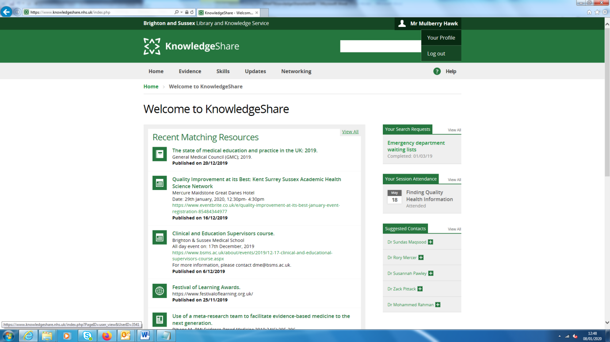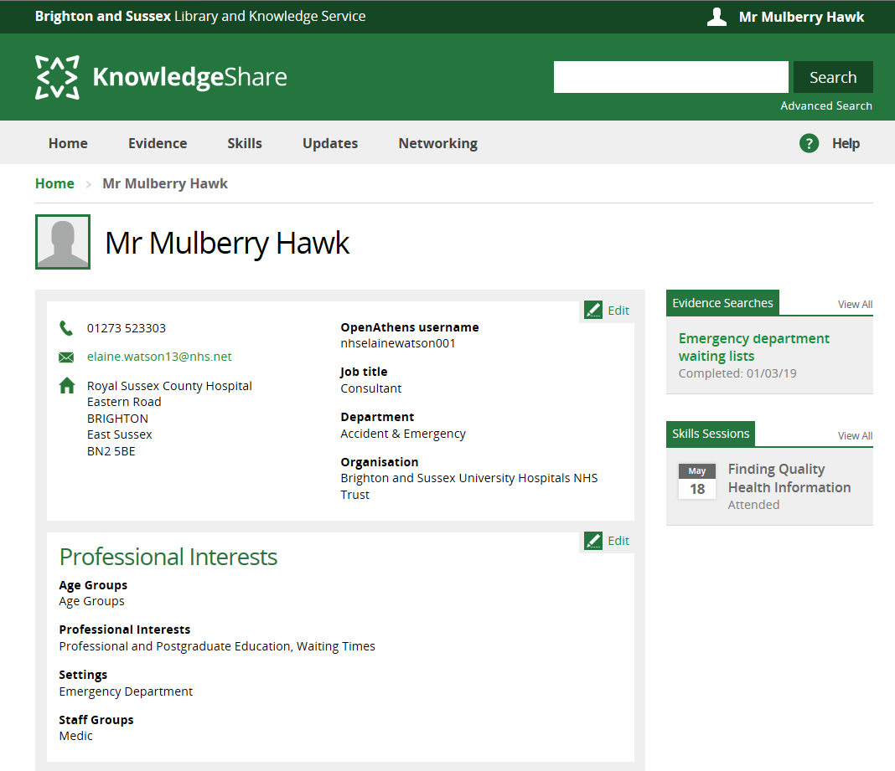

* **Book on to skills session** Once logged in to KnowledgeShare, scroll down the page to see a selection of skills sessions. Click on the desired session and then click the Book Place button.

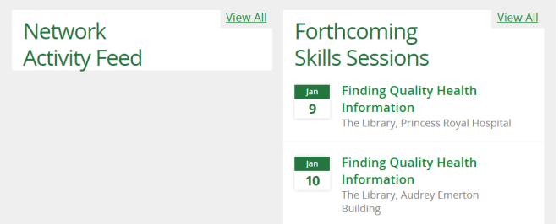

* **Request an evidence search** Once logged in to KnowledgeShare, click on Evidence on the grey tool bar and then click on Request an Evidence Search. Fill in the form with details of the search.

