- Quality improvement
- Intensified follow-up of patients with type 1 diabetes and poor glycaemic control: a multicentre quality improvement collaborative based on data from the Norwegian Diabetes Register for adults (BMJ Open Quality, June 2023)
- Using home blood pressure checks and text reminders to reduce postpartum maternal mortality (Institute for Healthcare Improvement, June 2023)
- Quality improvement intervention to increase colorectal cancer screening at the primary care setting: a cluster-randomised controlled trial (BMJ Open Quality, June 2023)

- Integrated care
- The practice of collaborative leadership: across health and care services (King’s Fund, July 2023)
- Driving better health outcomes through integrated care systems: the role of district councils (King’s Fund, July 2023)
- From inception to implementation: a year of integrated care systems (Care England, July 2023)
- Year one of integrated care systems has been tough- here's what they need in year two (NHS Providers, June 2023)

- Patients & people
- NHS announces nominations of health service heroes ahead of 75th birthday (NHS England, June 2023)
- Unpaid care and poverty: unpaid carers’ priorities for change through participatory co-design (Joseph Rowntree Foundation, June 2023)
- A duty of care: in-work poverty in London’s public sector (Social Market Foundation, June 2023)
- Report emphasises the importance of people and place in policy (UK Research and Innovation, June 2023)
- Medical Research Council urges researchers to consider diversity in experiments (UK Research and Innovation, June 2023)
- Leading for all: supporting trans and non-binary healthcare staff (NHS Confederation, June 2023)
- All is not well: sickness absence in the NHS England (Nuffield Trust, June 2023)

- NHS strategy & performance
- Getting the fundamentals right: how to better prepare for discharge pressures next winter (Nuffield Trust, July 2023)
- Growing problems, one year on: the state of children’s healthcare and the Covid-19 backlog (Nuffield Trust, June 2023)
- NHS Equality, Diversity and Inclusion Improvement Plan (NHS England, June 2023)
- All is not well: sickness absence in the NHS in England (Nuffield Trust, June 2023)
- How much planned care in England is delivered and funded privately? (Nuffield Trust, June 2023)
- More staff in general practice, but is the emerging mix of roles what’s needed? (Nuffield Trust, June 2023)
- How does the NHS compare to the health care systems of other countries? (King’s Fund, June 2023)
- Reducing the elective care backlog for people with a learning disability: Calderdale and Huddersfield NHS Foundation Trust (NHS Confederation, June 2023)
- Modernising continuity: a new conceptual framework (British Journal of General Practice, June 2023)
- Progress with the New Hospital Programme (National Audit Office, July 2023)

- Population health & prevention
- Understanding the drivers of healthy life expectancy (Office for Health Improvement and Disparities, June 2023)
- Rough sleepers in homeless hotspots to benefit from NHS mental health support (NHS England, June 2023)
- Strengthening the role of the ambulance sector in reducing health inequalities: national consensus statement and next steps (Association of Ambulance Chief Executives, June 2023)
- Ethnic inequalities in health and care show diversity in need and disadvantage (The BMJ, June 2023)
- How health has changed in your area 2015-2021 (Office for National Statistics, June 2023)
- Arts and Humanities Research Council projects kickstart future of health and social care dialogue (UK Research and Innovation, June 2023)
- Population health management in primary health care: a proactive approach to improve health and wellbeing: primary healthcare policy paper series (World Health Organisation, June 2023)

- Technology & data
- Innovative healthcare tech could transform medical treatments (UK Research and Innovation, June 2023)
- Cancer treatment patients get remote monitoring support for symptom management at home (Inhealthcare, June 2023)
- How do people feel about AI? (Ada Lovelace Institute, June 2023)
- Surrey Heartlands ICB opens £3 million virtual care digital platform tender (Health Tech Newspaper, June 2023)
- The effects of computerised decision support systems on nursing and allied health professional performance and patient outcomes: a systematic review and user contextualisation (National Institute for Health and Care Research, June 2023)
- Royal Society of Medicine and Bodyswaps prepare to launch VR-powered training (Royal Society of Medicine, June 2023)
- Remote care has the power to save millions of GP appointments (Inhealthcare, June 2023)

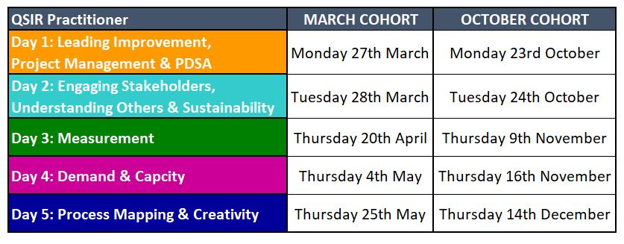
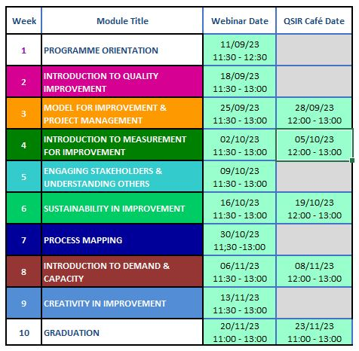
QSIR Virtual- contact QSIRVirtual@geh.nhs.uk QSIR Practitioner- contact QSIR@Swft.nhs.uk

