- Quality improvement
- Patient involvement in quality improvement: a survey comparing naturalistic and reflective approaches (BMJ Open Quality, May 2023)
- The implementation of a rib fracture pathway at a small district general hospital to improve patient care (Cureus, May 2023)
- Quality improvement strategies for diabetes care: effects on outcomes for adults living with diabetes (Cochrane Database of Systematic Reviews, May 2023)
- NHS quality improvement programme reduces the risk of cerebral palsy in newborns (National Institute for Health and Care Research, May 2023)
- Implementation of a primary care asthma management quality improvement programme across 68 general practice sites (NPJ Primary Care Respiratory Medicine, May 2023)
- Improving the transition of young people to adult services (NHS Fab, May 2023)

- Integrated care
- Earlier screening, risk assessment and health optimisation in perioperative pathways: a guide for providers and integrated care board (NHS England, May 2023)
- Where does specialist public health sit across the UK? (Association of Directors of Public Health, May 2023)
- Evaluating primary care transformation: synthesis of findings from UK pilot project reviews (British Journal of General Practice, May 2023)
- Providers deliver: patient flow (NHS Providers, May 2023)
- Involving partners, people and patients in integrated care: a case study from West Yorkshire Health and Care Partnership (Good Governance Institute, May 2023)

- Patients & people
- The case for more geriatricians: strengthening the workforce to care for an ageing population (British Geriatrics Society, May 2023)
- Caring in a complex world: perspectives from unpaid carers and the organisations that support them (King’s Fund, May 2023)
- In train? Progress on mental health nurse education (Nuffield Trust, May 2023)
- Enabling patients as partners on virtual teams: a scoping review (Journal of Patient Experience, May 2023)
- Patient perspectives of the hospital discharge process: a qualitative study (Journal of Patient Experience, May 2023)
- For better or worse? Subjective expectations and cost-benefit trade-offs in health behavior (Institute for Fiscal Studies, May 2023)
- Equity of access key to addressing physical health needs of learning disability population (Royal Society of Medicine, May 2023)

- NHS strategy & performance
- NHS Performance Tracker (Nuffield Trust, May 2023)
- Realising the potential of virtual wards (NHS Confederation, May 2023)
- NHS and Government back AHSNs to continue to lead innovation, under new name (Academic Health Science Network, May 2023)
- Patterns of less-than-full-time working by NHS consultant (Institute for Fiscal Studies, May 2023)
- Are you satisfied with your integrated performance report? (Good Governance Institute, May 2023)
- How is diagnostic testing affecting the hospital system? (Midlands Decision Support Network, Spring 2023)
- Population health & prevention
- Global health framework: working together towards a healthier world (Department of Health and Social Care, May 2023)
- Our ambitions for a healthier nation (Association of Directors of Public Health, May 2023)
- Active and healthy counties: encouraging, supporting and enabling residents to live healthy lives (County Councils Network, May 2023)
- Designing out the most severe forms of hardship in local areas (New Local and Joseph Rowntree Foundation, May 2023)
- Landmark resolution on strengthening rehabilitation in health systems (World Health Organisation, May 2023)
- Are mental health problems the “new normal” for young people? New qualitative study from Sweden explores their thoughts (The Mental Elf, May 2023)

- Technology & data
- NHS partners with Inhealthcare to expand remote monitoring across Scotland (Inhealthcare, May 2023)
- The electronic health record can be the hero, not the enemy (Institute for Healthcare Improvement, May 2023)
- Mental health care and the benefits system: linked data provides opportunities for new research (The Mental Elf, May 2023)

7. Events & Training
- Value Stream Mapping Micro QI Training – 5 July 2023 (Evidence 4 QI)
- Innovations in sustainable healthcare: the SusQI showcase - RECORDING (Centre for Sustainable Healthcare, May 2023)
- Co-production week (Social Care Institute for Excellence, 3 July 2023)
- QSIR Training

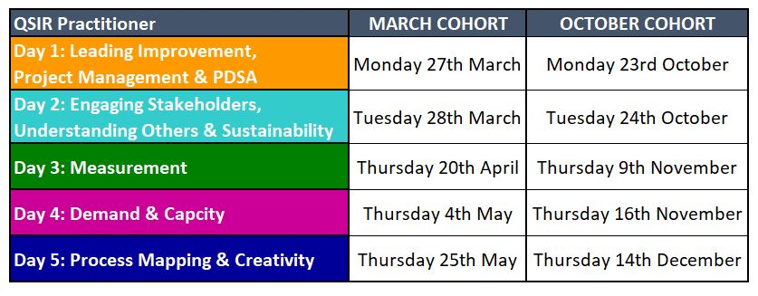
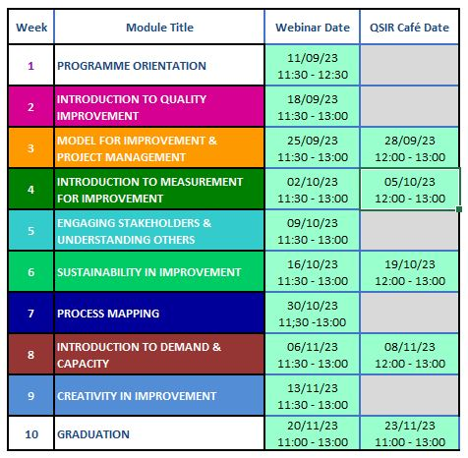
QSIR Virtual- contact QSIRVirtual@geh.nhs.uk QSIR Practitioner- contact QSIR@Swft.nhs.uk

